Picture Books Relating to Visual Arts

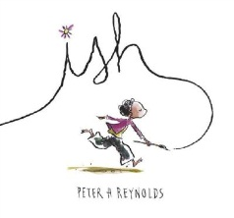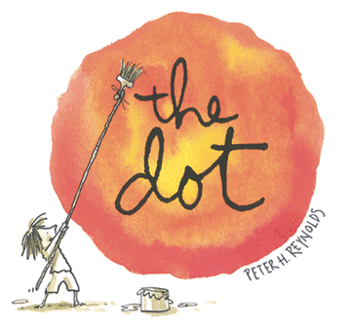**Specifically About Art & Creativity**

**3D ABC – A Sculptural Alphabet** by Bob Raczka

**A Little Bit of Oomph** written & illustrated by Barney Saltzberg

**Art is…** by Bob Raczka

**Artful Reading** by Bob Raczka

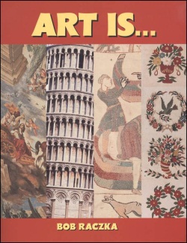**Art’s Supplies** written & illustrated by Chris Tougas

**Adventures in Cartooning: How To Turn Doodles into Comics** by James Sturm, Andrew Arnold and Alexis Frederick-Frost

**Beautiful Oops** by Barney Saltzberg

**Can You Hear It?** by Dr. William Lach & The Metropolitan Museum of Art (includes CD)

**Emily’s Art** by Peter Catalanotto

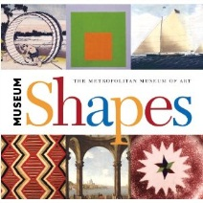**How Artists See Weather?** by Colleen Carroll

**I Ain’t Gonna Paint No More!** by Karen Beaumont; illustrated by David Catrow

**ISH** written & illustrated by Peter H. Reynolds

**Inuksuk Journey: An Artist at the Top of the World** written & illustrated by Mary Wallace

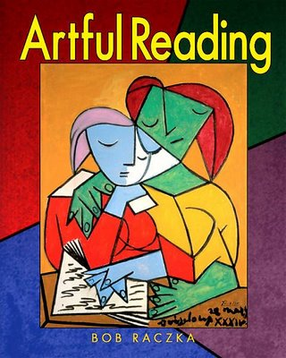**Museum Shapes** by the Metropolitan Museum of Art

**Painting the Wind** written by Patricia & Emily MacLachlan; illustrated by Katy Schneider

**Seen Art?** by Jon Scieszka; illustrated by Lane Smith

**Sky Colour** written & illustrated by Peter H. Reynolds

**Sky Tree: Seeing Science Through Art** written & illustrated by Thomas Locker

**The Art Lesson** written & illustrated by Tomie dePaola

**The Big Orange Splot** written & illustrated by Daniel Pinkwater

**The Day the Crayons Quit** written by Drew Daywalt & illustrated by Oliver Jeffers

**The Dot** written & illustrated by Peter H. Reynolds

**The Museum** written by Susan Verde; illustrated by Peter H. Reynolds

**The Red Book** written & illustrated by Barbara Lehman (gallery visit; wordless)

**What is Line?** (“Get Art Smart” series) by Susan Markowitz-Meredith

**What is Shape?** (“Get Art Smart” series) by Tea Benduhn

**What is Colour?** (“Get Art Smart” series) by Tea Benduhn

(**What is** **Texture?, etc**.…)

**Artists & Art History**

**A Brush Full of Colour: The World of Ted Harrison** by Margriet Ruurs and Katherine Gibson

**Capturing Joy – The Story of Maud Lewis;** written by Jo Ellen Bogart, illustrated by Mark Lang (Nova Scotian folk artist)

**Claude Monet - Sunshine & Waterlilies** (Smart About Art series) by True Kelley

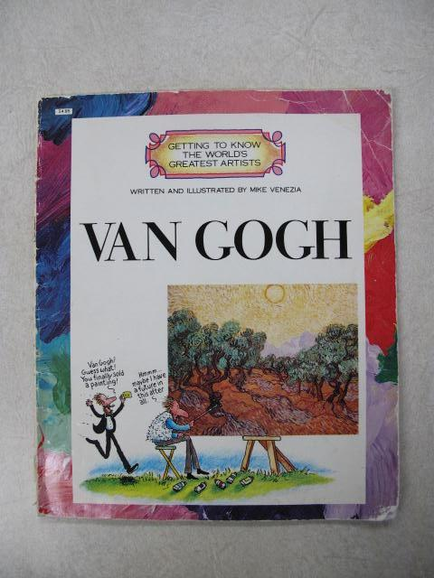**Dali and the Path of Dreams** written by Anna Obiols; illustrated by Subi

**Emily Carr’s Attic** by Diane Carmel Léger & Michael Léger

**Getting To Know the World’s Greatest Artists** series by Mike Venezia

(series includes Bottecelli, Bruegal, Calder, Cassatt, Cézanne, Chagall,

da Vinci, Dali, Degas, Delacroix, Theotokopoulos/El Greco, Gauguin, di Bondone, Goya, Homer, Hopper, Kahlo, Klee, Lange, Lawrence, Lichtenstein, Magritte, Matisse, Grandma Moses, O’Keeffe, Picasso, Pippin, Pissarro, Pollock, Raphael (Sanzio), Rembrandt, Remington, Renoir, Finggold, Rivera, Rockwell, Rousseau, Seurat, Titian, Toulouse-Lautrec, Van Gogh, Velàzquez, Vermeer, Warhol, Whistler, Wood)

**Henri Matisse - Drawing with Scissors** (Smart About Art series) by Jane O

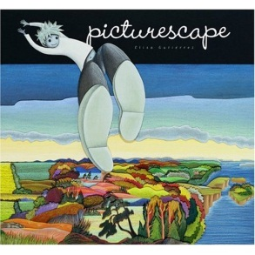**Here’s Looking at Me: How Artists See Themselves** by Bob Raczka

**I Am Marc Chagall** written & illustrated by Bimba Landmann (mixed media with found objects)

**Katie Meets the Impressionists** by James Mayhew

**Linnea in Monet’s Garden** by Christina Bjork and Lena Anderson

**More than Meets the Eye: Seeing Art with All Five Senses** by Bob Raczka

**Name that Style: All About ISMS in Art** by Bob Raczka

**No One Saw… Ordinary Things through the Eyes of an Artist** by Bob Raczka

**Pablo Picasso - Breaking All the Rules** (Smart About Art series) by True Kelley

**Picturescape** written & illustrated by Elisa Gutiérrez (wordless; inspired by regions of Canada & Canadian artists; wwwl.picturescape.ca)

**Pierre Auguste Renoir - Paintings that Smile** (Smart About Art series) by True Kelley

**Uncle Andy’s** written & illustrated by James Warhola (Andy Warhol)

**Unlikely Pairs: Fun with Famous Works of Art** by Bob Raczka

**Vincent’s Colours** by The Metropolitan Museum of Art

**Vincent van Gogh - Sunflowers & Swirly Stars** (Smart About Art series) by Joan Holub

**Where in the World?** by Bob Raczka

**Architecture**

**Architects Make Zigzags: Looking at Architecture from A to Z** by Roxie Munro

**Castle** written & illustrated by David Macaulay (additional titles include **Bridges, Cathedral, City, Mosque, Pyramid**)

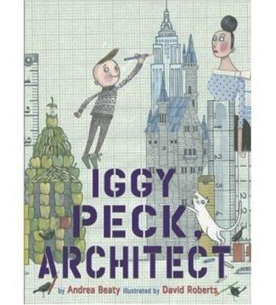**Iggy Peck, Architect** by Andrea Beaty; illustrated by David Roberts

**Pippo the Fool *written by Tracey E. Fern; illustrated by Pau Estrada*** *(fictionalized story of Brunelleschi’s construction of the Duomo in Florence)*

**Roberto the Insect Architect** written & illustrated by Nina Laden

**Rosie Revere, Engineer** by Andrea Beaty; illustrated by David Roberts

**The East-West House: Noguchi’s Childhood in Japan** by Christy Hale

**The City ABC Book** by Zoran Milich

**The Three Little Pigs: An Architectural Tale** retold & illustrated by Steven Guarnaccia

**On Illustration & Illustrators**

**A Caldecott Celebration: Seven Artists and Their Paths to the Caldecott Medal** by Leonard S. Marcus (ISBN 978-0-399-24600-5)

**Artist to Artist: 23 Major Illustrators Talk to Children about Their Art** by the Eric Carle Museum of Picture Book Art

**Illustrations Featuring Specific Drawing Techniques, or Emphasis on Line, Space, Value, Pattern, etc.**

**A Northern Lullaby** by Nancy White Charlstrom; illustrated by Leo & Diane Dillon

**Alexander and the Terrible, Horrible, No Good, Very Bad Day** by J. Viorst; illustrated by Ray Cruz (drawing; hatching)

**Blueberries for Sal** written & illustrated by R. McCloskey

**Changes** written & illustrated by Anthony Browne

**Chester** by Mélanie Watt (Canadian) (illustrating)

**Extra Yarn** written by Mac Barnett; illustrated by Jon Klassen

**Falling Up** written & illustrated by Shel Silverstein (drawing; line)

**Frog Goes to Dinner** written & illustrated by Mercer Mayer (drawing; hatching)

**Green** (**Vert** en francais) written & illustrated by Laura Vaccaro (colour; canvas texture and texture/impasto of paint are both visible in award-winning illustrations)

**Grumpy Bird** written & illustrated by Jeremy Tankard

**Hailstones & Halibut Bones: Adventures in Poetry & Colour** by Mary O’Neill; illustrated by John Wallner (poetry collection about colour)

[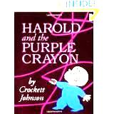](http://www.bookcentre.ca/)**Happy!** By Romero Britto (line, shape, colour & pattern)

**Harold and the Purple Crayon** written & illustrated by Crockett Johnson (drawing; line)

**I Wish I Were a Butterfly** by J. Howe; illustrated by Ed Young

**If You’re Not from the Prairie** by D. Bouchard; illustrated by Henry Ripplinger (Canadian) (space; landscape)

**Jumanji** written & illustrated by Chris Van Allsburg (drawing; value)

**Like Jake and Me** written by Mavis Jukes; illustrated by Lloyd Bloom

**Lines that Wiggle** written by Candace Whitman; illustrated by Steve Wilson

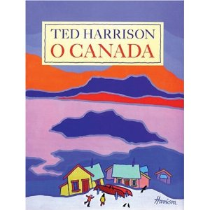**Make Way for Ducklings** written & illustrated by R. McCloskey (drawing)

**Millions of Cats** written & illustrated by Wanda Ga’g (drawing)

**Mix it Up** written & illustrated by Hervé Tullet (colour mixing)

**My Many-Coloured Days** by Dr. Seuss; illustrated by Steve Johnson & Lou Fancher (colour)

**Not a Box** written & illustrated by Antoinette Portis (shape)

**Not a Stick** written & illustrated by Antoinette Portis (line and shape)

**O Canada** Lyrics=national anthem; illustrated by Ted Harrison (stylized; colour; landscape)

**On My Beach There are Many Pebbles** written & illustrated by L. Lionni (drawing; shading)

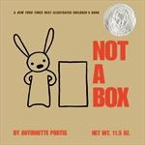**Our Tree Named Steve** by Alan Zweibel; illustrated by David Catrow (colour)

**One Wish** written & illustrated by Frances Wolfe (Canadian) (painting)

**Painting the Town** written & illustrated by Denise Minnerly (mixing colours, NYC architecture)

**Posy!** By Linda Newberry; illustrated by Cathering Rayner

**Press Here** written & illustrated by Herve Tullet (primary & secondary colours)

**Purple, Green and Yellow** by R. Munsch; illustrated by Helene Desputeaux (Canadian)

**Rosie and Michael** by J. Viorst; illustrated by (drawing; hatching; cross-hatching)

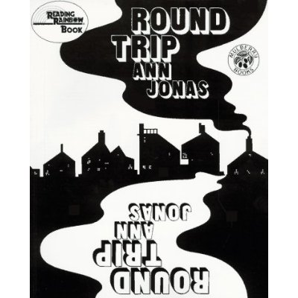**Round Trip** written & illustrated by Ann Jonas (shape; positive/negative space)

**Shapes, Shapes, Shapes** written & illustrated by Tana Hoban

**Strega Nona: An Old Tale** written & illustrated by Tomie de Paola

**The Balloon Tree** by Phoebe Gillman (Canadian) (painting; borders)

**The Black Book of Colour** by Menena Cottin & Rosana Faria (colour; texture; embossed illustrations; includes Braille text)

**The Castle Builder** written & illustrated by Dennis Nolan (drawing, stippling/pointillism…)

[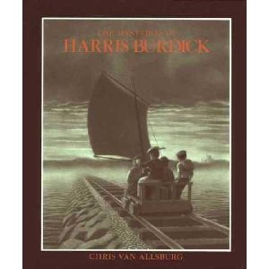](http://www.bookcentre.ca/)**The Lazy Bear** written & illustrated by Brian Wildsmith

**The Line** written & illustrated by Paula Bossio (wordless; charcoal)

**The Line Sophie Drew** by Peter & Sophie Barrett

**The Mitten** written & illustrated by Jan Brett (Canadian?) (painting, borders…)

**The Mysteries of Harris Burdick** written & illustrated by Chris Van Allsburg

(title & captions only; also available in large print format)

**The Shape Game** written & illustrated by Anthony Browne

**The Wing on the Flea** written & illustrated by Ed Emberley (shapes)

**Sky** written & illustrated by Ariane Dewey (colour, shape…)

**The Z Was Zapped: A Play in 26 Acts** written & illustrated by Chris Van Allsburg (drawing; value)

**Tikta’Liktak** Retold & illustrated by James Houston (drawing; value)

**Toes in My Nose** written by Sheree Fitch; illustrated by Molly Lamb Bobak (New Brunswick)

**White Rabbit’s Colour Book** written & illustrated by Alan Barker (primary & secondary colours)

**When you Were Small** by Sara O’Leary; illustrated by Julie Morstad (Canadian) (drawing; hatching; colour wash)

**Where I Live** written & illustrated by Frances Wolfe (Canadian) (painting)

**Where the Sidewalk Ends** written & illustrated by Shel Silverstein (drawing; line)

**Where the Wild Things Are** written & illustrated by Mercer Mayer (drawing; hatching)

**Would They Love a Lion?**  written & illustrated by K. MacDonald Denton

**Zoom Away** by T. Wynne-Jones; illustrated by Eric Beddows (Canadian) (drawing)

**Zoom Upstream by** by T. Wynne-Jones; illustrated by Eric Beddows (Canadian) (drawing)

**Zoom at Sea** by T. Wynne-Jones; illustrated by Eric Beddows (Canadian) (drawing)

Novel with sections of wordless illustrations: **The Invention of Hugo Cabret** by Brian Selznick

**Picture Books Featuring Collage**

**The Very Quiet Cricket** written & illustrated by Eric Carle

**The Very Hungry Caterpillar** written & illustrated by Eric Carle

**Mister Seahorse** written & illustrated by Eric Carle

**The Grouchy Ladybug** written & illustrated by Eric Carle

**It’s Mine** written & illustrated by Leo Lionni

**Frederick** written & illustrated by Leo Lionni

**Matthew’s Dream** written & illustrated by Leo Lionni

**Picture Books Featuring Watercolour**

**A Morning to Polish and Keep** by J. Lawson; illustrated by Sheena Lott (Canadian)

**A Promise is a Promise** by Robert Munsch & Michael Kusugak (Canadian)

**A Salmon for Simon** by Betty Waterton; illustrated by Ann Blades

**Back to the Beach** by H. Jardine Stoddart (New Brunswick)

**Barn Dance** by Bill Martin, Jr. & John Archambault; illustrated by Ted Rand

**East to the Sea** by H. Jardine Stoddart (New Brunswick)

**Foggy Cat**by Glenda Thornton; illustrated by Robert Lyon (New Brunswick)

**Lollipopsicles** by Gretchen Kelbaugh; illustrated by Judi Pennanen (New Brunswick)

**Looking for Loons**by Jennifer Lloyd; illustrated by Kirsti Anne Wakelin

**Loon Summer** by Barbara Santucci; illustrated by Andrea Shine

**My Home Bay** by Anne Laurel Carter; illustrated by Lea & Alan Daniel (Canadian)

**Owl Moon** by Jane Yolen

**Return to the Sea** by H. Jardine Stoddart (New Brunswick)

**Saint Francis** written & illustrated by Brian Wildsmith

**Secret Place** written by Eve Bunting; illustrated by Ted Rand

**Stella and Sam**series; by Marie-Louise Gay (Canadian)

**Stringbean’s Trip to the Shining Sea** by Vera B. Williams

**The Fabulous Song** by Don Gillmor; illustrated by Marie-Louise Gay (Canadian)

**The Ghost Eye Tree** by Bill Martin, Jr. & John Archambault; illustrated by Ted Rand

**The Pirates of Captain McKee!** by Julie Lawson; illustrated by Werner Zimmermann (Canadian)

**The Snow Queen** *(Hans Christian Andersen’s)* written by Naomi Lewis; illustrated by Christian Birmingham

**The Tale of Peter Rabbit** written & illustrated by Beatrix Potter

**The Third-Story Cat** written & illustrated by Leslie Baker

**The Wall** by E. Bunting; illustrated by Ronald Himler

**Water** written & illustrated by Frank Asch

**Picture Books Featuring Plasticine Modeling Clay**

**Effie** written by Beverley Allinson; illustrated by Barbara Reid (Canadian)

**Have You Seen Birds?** By Joanne Oppenheim; illustrated by Barbara Reid (Canadian)

**One Gray Mouse** written by Katherine Burton; illustrated by Kim Fernandes (Canadian)

**Perfect Snow** written & illustrated by Barbara Reid (includes ink drawings/thumbnails)

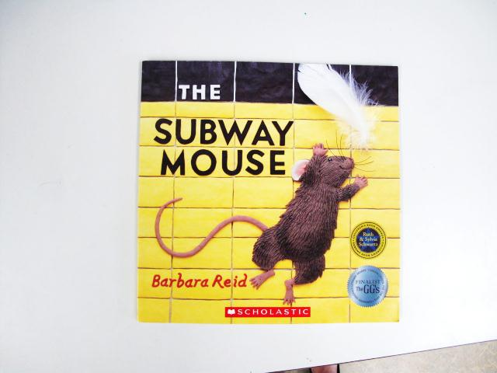**Picture a Tree** written & illustrated by Barbara Reid (Canadian)

**Subway Mouse** written & illustrated by Barbara Reid (Canadian)

**The Party** written & illustrated by Barbara Reid (Canadian)

**The Fox Walked Alone** written & illustrated by Barbara Reid (Canadian)

**T’was the Night Before Christmas** *illustrated by Barbara Reid (Canadian)*

**Resources for Information on Authors, Illustrators & Picture Books**

Canadian Children’s Book Centre ([www.bookcentre.ca](http://www.bookcentre.ca))

The Magic Suitcase ([www.magicsuitcase.ca](http://www.magicsuitcase.ca)) (Canadian)

Some book suggestions from ***The Arts as Meaning Makers: Integrating Literature and the Arts Throughout the Curriculum*** by Claudia E. Cornett and Katharine L. Smithrim (2001); ***Art & Illustration for the Classroom: A Guide for Teachers & Parents*** by Rhian Brynjolson (1998), ***Teaching Art: A Complete Guide for the Classroom*** by Rhian Brynjolson (2009) and ***SRA Art Connections*** Teacher Editions.