**A Grade 3-5 ARTful Hour...**

Fall 2014

With Heidi Stoddart

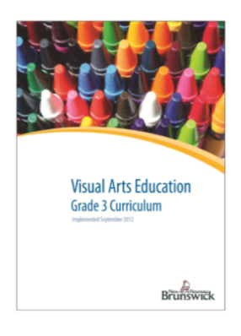 CREATE - the creative process (plan, explore, experiment, re-work, produce…)

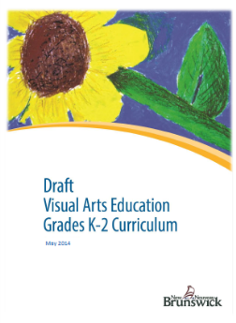 CONNECT - explore various artists, cultures, historical periods…

COMMUNICATE - share, respond, reflect, discuss; own works & works by others

**Elements of Art and Design: Mapped for Grades K-5**

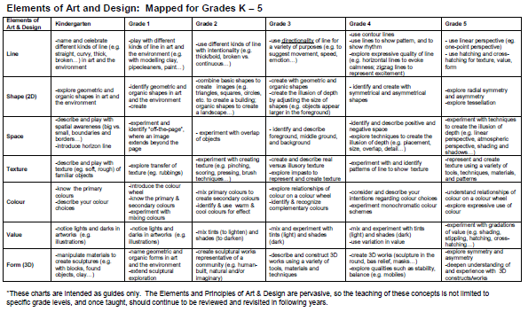

**Painting Supplies…**

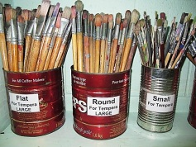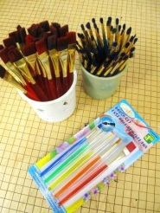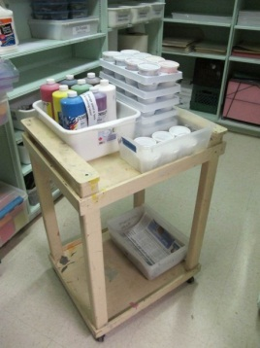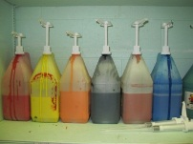

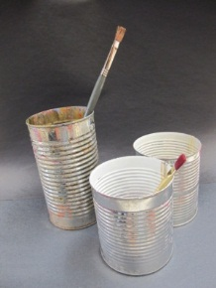

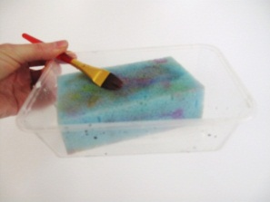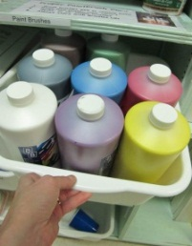

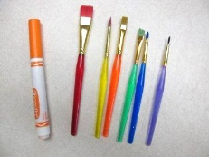

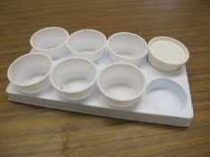

**Paint & Palettes Paint Brushes Water Container & Sponges**

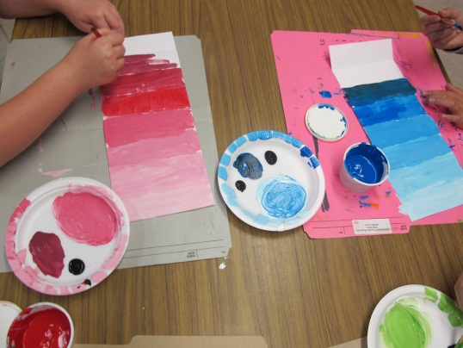**1. Value – Mixing Shades & Tints**

**Materials:**

* *Cartridge Paper (e.g. 6”x12”)*
* *Tempera Paint*
* *Paint Brushes*
* *Palettes (small plate per student)*
* *Water containers*
* *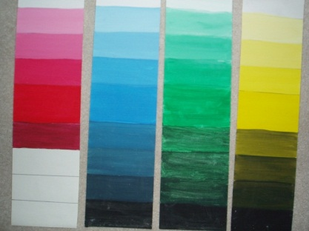Sponge/container*
* *Newspaper or old file folders to protect desks*

**Create…**

* *Fold the paper to create approx. 8 sections*
* *Start with the ‘pure’ colour or hue near the middle*
* *Create lighter values (TINTS) using white (start with a dollop of white paint and mix in the colour that was already on your brush, gradually adding more and more colour for each tint)*
* *Create darker values (SHADES) using black (black is very strong – just a little required for big effect)*
* *TIP… when mixing, start with the LIGHTEST hue (e.g. white) and gradually add small amounts of the colour.*

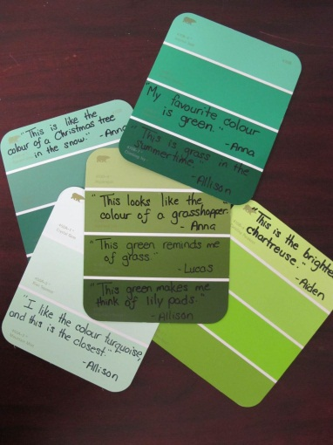**“I Can” Skills…**

* Practice painting routines
* Mix and experiment with tints & shades
* Teacher Tip: Use ‘paint chips’ as inspiration to write about colour

**Artist’s Clean-Up:**

1. Brush in water
2. Palette to garbage
3. Value Scale to Drying Spot
4. Wash Hands
5. Free Drawing

* **Teacher Tip**: Make it a routine - have sketchbooks or blank paper for students to draw/colour when finished.

**2. Landscape… Variation in Value**

**Materials:**

* 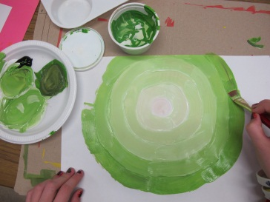*Newspaper to protect desks*
* *Cartridge paper (10”x14”)*
* *Liquid tempera paint (variety of colour choices plus black & white)*
* *Small palettes (styrofoam plate)*
* *Paint brushes (various sizes; e.g. large and small/detail)*
* *Water containers*
* *Sponges and containers*

**Create…**

* Sketch in a low horizon line
* Background/sky… Use white to start with the ‘moon, then gradually mix in one colour, creating rings around the moon the show a gradation of value from light to dark.
* Foreground… Choose another colour (to represent ground, grass, sand, or snow…), and mix this with white to create tints, creating a gradation of value that gets darker the further it is from the moon (light source).
* 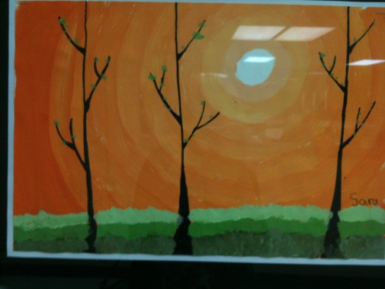Once dry, use a detail brush and black paint to create silhouettes of objects in the foreground (e.g. trees? fence? building?...)

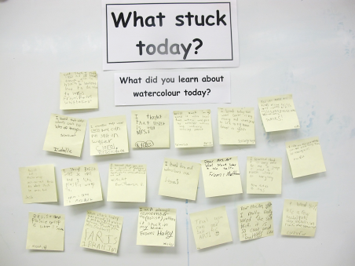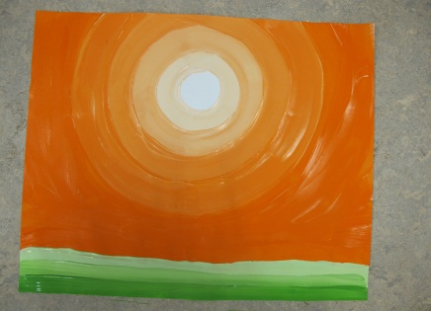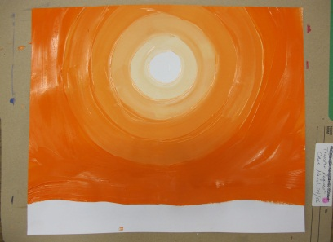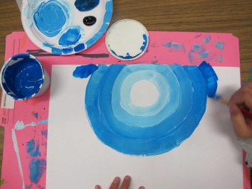

**“I Can” Skills…**

* Follow painting routines
* Mix TINTS (to lighten) by adding white paint
* Experiment with gradations of VALUE in the background and the foreground
* Use a detail brush to create a silhouette with emphasis on line and shape

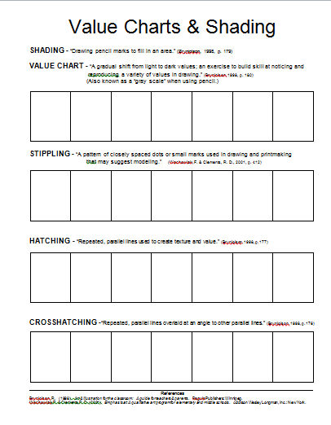**3.** **Value Charts – Gradations of Value**

**Materials:**

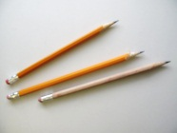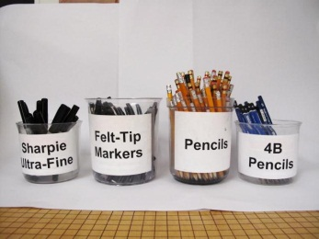-value scale (template attached; also available on ‘Elementary Visual Arts’ website)

-pencil

-fine tip black marker

**Practice…**

1. shading (pencil grip, pressure, layer/overlap)

2. stippling

3. hatching

4. cross-hatching

**“I Can” Skills…**

* Handle and control a drawing tool
* Experiment with gradations of value (e.g. shading, stippling, hatching, cross-hatching…)

**Picture Books – Illustrations using gradations of value**

***The Mysteries of Harris Burdick*** by Chris Van Allsburg

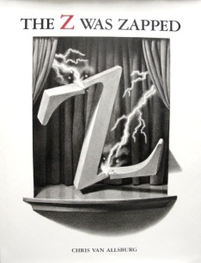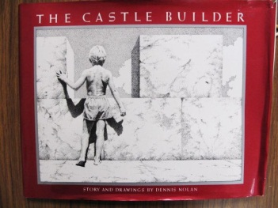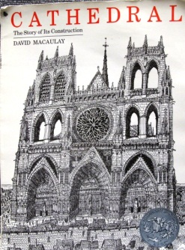***The Z Was Zapped*** by Chris Van Allsburg

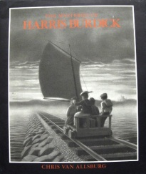***The Castle Builder*** by Denis Nolan

***Cathedral*** by David Macaulay

**Connect!**

**Communicate!**

***[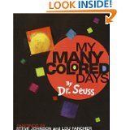](http://www.amazon.ca/Many-Colored-Days-Dr-Seuss/dp/0679875972/ref=sr_1_1?ie=UTF8&qid=1379893157&sr=8-1&keywords=My+Many+Coloured+Days)***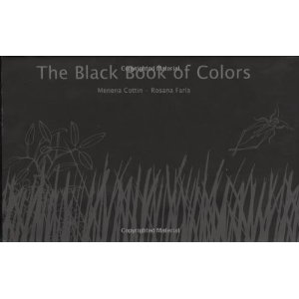**Picture Books relating to COLOUR…**

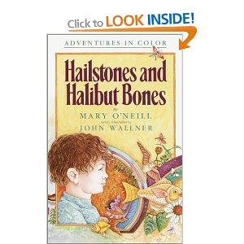***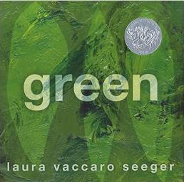Green*** by Laura Vaccaro Seeger

***Hailstones and Halibut Bones*** by Mary O’Neill

***My Many Coloured Days*** by Dr. Seuss

***Sky Colour*** by Peter H. Reynolds

[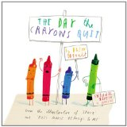](http://www.amazon.ca/Day-Crayons-Quit-Drew-Daywalt/dp/0399255370/ref=sr_1_1?ie=UTF8&qid=1379893306&sr=8-1&keywords=The+Day+the+Crayons+Quit)***White Rabbit’s Colour Book*** by Alan Baker

***The Black Book*** of Colours by Menena

Cottin and Rosana Faria

[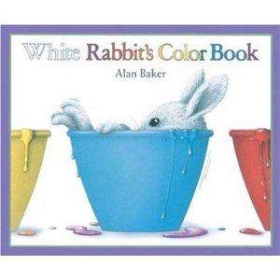](http://www.amazon.ca/gp/product/images/1856979539/ref=dp_image_0?ie=UTF8&n=916520&s=books)[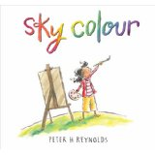](http://www.amazon.ca/Sky-Colour-Peter-H-Reynolds/dp/1844281604/ref=sr_1_2?ie=UTF8&qid=1379893364&sr=8-2&keywords=Sky+Colour)

**Teacher Resource…**

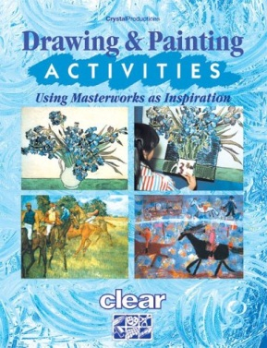

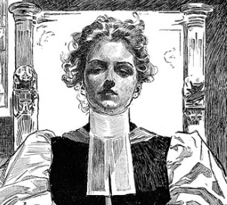Check out the Lesson 10 on Pages 22-23

VALUE… “Sketching and Hatching”

**In Days to Come the Churches May Be Fuller**

*by Charles Gibson; 1896; pen & ink on paper*

Connect! Communicate!

[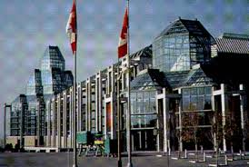](http://www.google.ca/url?sa=i&rct=j&q=&esrc=s&frm=1&source=images&cd=&cad=rja&uact=8&docid=TVaSHfZbrIaElM&tbnid=4-Vhvt4bfQggSM:&ved=0CAcQjRw&url=http://www.museevirtuel-virtualmuseum.ca/Search.do?mu=on&R=NGUIDE_NGOC&ei=vF4pVIGOGoa1sQS-44KIDA&psig=AFQjCNH8k8UskopzT43EDmf-f6YJsF0oOw&ust=1412083761335037)**National Gallery of Canada**

Distance Learning Program

Book a guest speaker from our National Gallery (Ottawa) to engage your class in discussing a range of artworks while exploring curriculum-linked themes. All you need is a computer with speakers and a webcam; this program is offered **free of charge**.

Preview video: <http://youtu.be/FGRr5PYt5zY> to see the program in action

Online registration form: (<http://www.gallery.ca/en/learn/reservations.php>) or 613-990-4888

**Elementary Program Themes:**

**People and Relationships -** How can people speak to us without saying a word?  Discover the role of body language and facial expression in relating stories in artworks.

**Spaces and Places -** How does the setting add to the story?  Explore different environments in artworks, from interiors to landscapes.

**What and Why -** Why do people make art?  Explore influences, the role materials play, and how we can interpret artists’ choices.  (*Best suited to students in Grades 4 to 6.)*

|  |
| --- |
| **Teacher Resources:**   * **Art Lessons online** @ Dept. Of Ed. Portal: Click on “Learning Resources”, scroll to “Elementary”, click on “The Arts”, scroll to “K-8 Visual Art Binders” * My **Art Website**: <http://elementaryvisualart.weebly.com>   Links found on the Homepage of my Website:   * **Twitter**: “art4schools” * **Pinterest:** “art4schools” * **Elementary Schools’ Online Art Gallery** |