A Grade Gr. 3-5 ARTful Hour...
May 2012
With Heidi Stoddart
Early Elementary = Personal Expression through Art and Picture Making

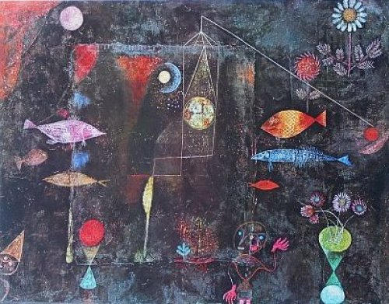
- Paul Klee, Crayon & Tissue Paper
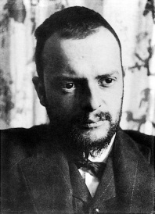
Lesson based on “Underwater Fantasy” retrieved from: http://teachkidsart.blogspot.ca/2012/04/underwater-fantasy-inspired-by-paul.html
Session 1 – Paul Klee & Drawing Picture
MATERIALS:
-Powerpoint (www.elementaryvisualart.weebly.com) or samples of Paul Klee’s artworks
-black wax crayons
Fish Magic; Paul Klee; 1925
-cartridge paper (e.g. 8”x10” or 10”x12”)

Background Info about Paul Klee
- Born in Switzerland (1879-1940); considered a Swiss and German artist
- Paintings are difficult to classify (associated with Cubism, Expressionism, Surrealism & Abstraction)
- Works were often small in size
- Used geometric shapes, letters, numbers and arrows, and combined them with figures of animals and people
- Included references to poetry, music and dreams; sometimes included words or musical notation
- Worked in isolation from his peers, interpreting new art trends in his own way
- Used a variety of media (oil, tempera, watercolour, ink, pastel, canvas, linen, burlap, cardboard…)
- Taught at Bauhaus school of art, design & architecture (colleague of Wassily Kandinsky)
- Was passionate about use of colour and was an effective teacher of colour theory & colour mixing
- Suffering from scleroderma, and this was reflected in his work. In 1935, created 25 works
- Encouraged by a visit from Picasso & Kandinsky in the late 1930’s, he created 1200 works in 1939

CREATE…
- Using a black crayon (or oil pastel), draw an underwater scene on your paper .
- Add some things that you wouldn't normally find underwater.... a clock, flowers, people, etc. Remember how Paul Klee used shapes, letters, numbers, music and reference to dreams…
- Consider use of space, shape and detail

Session 2 – Applying ‘Bleeding’ Tissue Paper
MATERIALS
-‘bleeding’ tissue paper cut into smaller sections for students to use/share (eg. Smaller squares and rectangles)
-water in containers
-paint brushes
-newspaper to protect desks
-drying area
Teacher Tips:
- Use ‘bleeding’ tissue paper so the colour will transfer to the cartridge paper and TEST the tissue first. I haven’t yet found a dollar store brand that works because they are ‘colour-fast’.
- Don’t provide large, full-size sheets of tissue for student use as it will result in significant waste. Instead, provide a large variety of colours in smaller pieces (e.g. squares and rectangles that students can then cut and/or tear to suit their work).

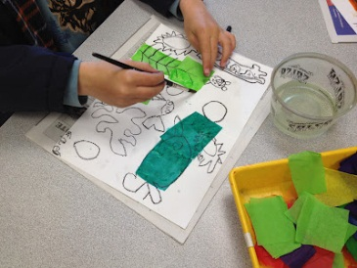
CREATE…
- Select the colours (‘bleeding’ tissue paper) you’d like to use for your picture, considering possible colour schemes, patterns and placement or arrangement of the colours
- Tear or cut the tissue paper into the required shapes/sizes, arranging the pieces on your drawing
- Use a large paint brush to apply water on top of the tissue, ‘tapping’ each piece into place. Ensure that the tissue paper is saturated with water.
Image retrieved May 2012 from
underwater-fantasy-inspired-by-paul
- Repeat steps 2 and 3, covering as much or as little of your
paper with color as you like. Use plenty of water so your tissue will "bleed"!
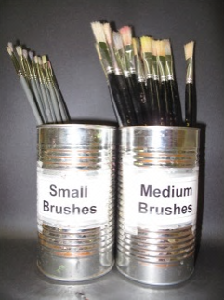
- Artist’s Clean-Up:
  - Artworks to drying space (COVER DRYING SPACE WITH NEWSPAPER FIRST – COLOUR ‘BLEED’S THROUGH!)
  - Wipe/dry hands & return all leftover tissue paper
  - Recycle newspaper
  - Wash brush and store properly (bristles up!)
  - Wash hands
  - Sketchbooks

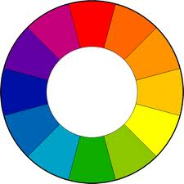
- Still Life – Flowers & Pastels
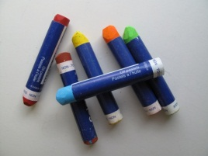
MATERIALS:
-Powerpoint or samples still life – flowers
-Flowers (real or artificial for observation & drawing)
-sketchbook (for practice)
-black construction paper (e.g. 9”x12”)
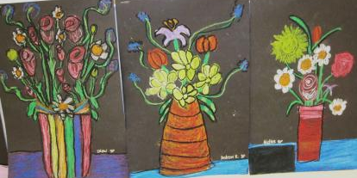
-pencil
-colour wheel (e.g. analogous colours = side-by-side on colour wheel)
-oil pastels
-paper towel (to wipe pastels)

CREATE…
Image retrieved May 2012 from
http://thecleverfeather.blogspot.ca/2012/04/oil-pastel-still-life-grade-3.html
- Look at artworks to discuss other artists’ still life work of flowers (e.g. Monet, ,
Georgia O’Keeffe, Van Gogh, Molly Lamb Bobak, Maud Lewis…)
- Start practicing by trying observational drawing of flowers in your sketchbook
- Draw a still life featuring a vase/pot and flowers (pencil on black construction paper)
- Use oil pastel (wipe first for ‘clean’ colour)
- Use at least 2 hues or tones for each part of the flower (e.g. light green and dark green for the stem) to create dimension; orange, yellow-orange and yellow for petal); blend by ‘layering’ as you colour
- Consider a LIGHT SOURCE (the direction the light would come from), and colour accordingly, with lighter values close to the light source, and darker values on the side that is away from the light source.
- Apply the colour to follow the shape of the object
(e.g. rounded strokes to show rounded surfaces)
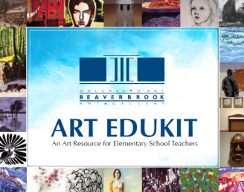
Teacher Resource Online: EDUKIT
The Beaverbrook Art Gallery (Fredericton, NB)
Page 84 – Molly Lamb Bobak
http://www.beaverbrookartgallery.org/documents/BeaverbrookArtGallery_Edukit_2011_En.pdf

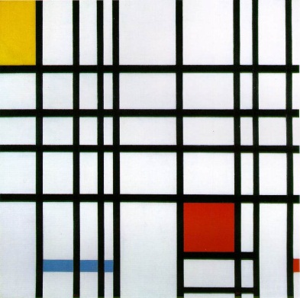
3. Piet Mondrian and Collage

MATERIALS...
-cartridge paper (e.g. 9”x9”)
-construction paper in black, red, yellow and blue (e.g. 6”x9”)
-rulers
-pencils
-scissors
-glue (‘placemats’ helps keep desks clean)
Composition with Red,Yellow & Blue, 1921
CREATE…
  - Starting with a blank, white background, cut out squares and rectangles to create a collage inspired by the geometric works by Piet Mondrian.
  - Consider using long, narrow rectangles to create a ‘line’ effect (can use a ruler to help create these)
  - Arrange the shapes first, experimenting with placement.
  - When you are satisfied with the work, glue the pieces into place.
  - Title & share your work (e.g. an Art Label)

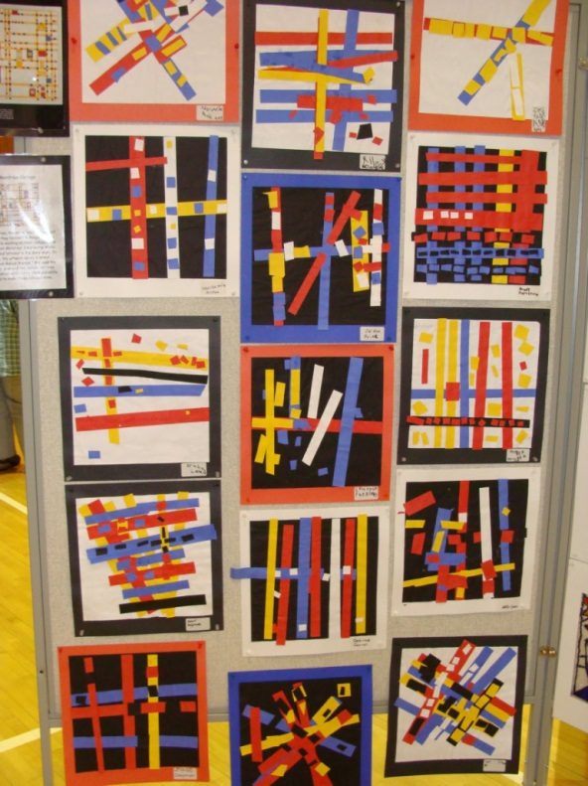
Image retrieved May 2012 from http://mrspicassosartroom.blogspot.ca/2010/03/spring-celebration-of-arts-fine-arts.html

More Resources about Famous Artists…
- Mightybooks.com “Art & Music” (http://www.mightybook.com/art_and_music.html)
- Mightbooks.com “Museum of Great Art” (http://www.mightybook.com/MightyBook_free/artgallery/gallery.html)
- Davis Arts’ “Artist Birthdays” (http://www.davisart.com/portal/teacherresources/T_resourcesDefault.aspx?curPage=ArtistBirthdays)
- “Getting to Know the World’s Greatest Artists” series (books & videos) (http://www.gettingtoknow.com/videos.htm)

