



[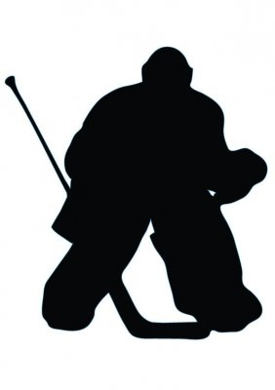](http://www.google.ca/url?sa=i&rct=j&q=&esrc=s&frm=1&source=images&cd=&cad=rja&docid=Heb9leTijSGIsM&tbnid=VEdWbUsjog3qBM:&ved=0CAUQjRw&url=http://www.wallmonkeys.com/index.php?main_page=product_info&products_id=30637&ei=Q2TyUp30GaSU2QW8vIHYBA&psig=AFQjCNG7ZIAJDubEF74886oSQTr13l8tHw&ust=1391703441601291)

[](https://www.stockcutouts.com/Hocky-Player-Silhouette)

[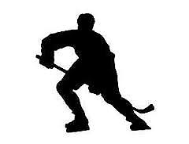](http://www.google.ca/url?sa=i&rct=j&q=&esrc=s&frm=1&source=images&cd=&cad=rja&docid=5z1lunIYRWm09M&tbnid=adq3O62814ql1M:&ved=0CAUQjRw&url=http://www.ebay.com/itm/HOCKEY-PLAYER-metal-steel-not-painted-7-inch-USA-silhouette-/290763776905&ei=92PyUuPwN8i92wWOsoHoAw&bvm=bv.60799247,d.b2I&psig=AFQjCNGhdSZl7ZKbV-d1GTZ0DfNt1ZiLMQ&ust=1391703313305416)

[](http://www.google.ca/url?sa=i&rct=j&q=&esrc=s&frm=1&source=images&cd=&cad=rja&docid=9em3Ut6mlF8JQM&tbnid=VEcUMr5JIxTcKM:&ved=0CAUQjRw&url=http://www.amazon.com/s?ie=UTF8&page=1&rh=n:2445485011,p_6:A1NKMJWQKA9I26,p_n_feature_twenty_browse-bin:3267887011&ei=qmPyUuT7HYKh2gXmtIGIBw&bvm=bv.60799247,d.b2I&psig=AFQjCNGhdSZl7ZKbV-d1GTZ0DfNt1ZiLMQ&ust=1391703313305416)

[](http://www.google.ca/url?sa=i&rct=j&q=&esrc=s&frm=1&source=images&cd=&cad=rja&docid=1X6ekVVCEhQNuM&tbnid=9LOOgLWitBF6gM:&ved=0CAUQjRw&url=http://www.epicski.com/t/41985/ideal-skier-silhouette-a-call-for-assistance/120&ei=qE_4UoblIImxrQG7-IC4DA&psig=AFQjCNGszX80D6heHDCGxDknkt0PtTNnkg&ust=1392091382338869)

[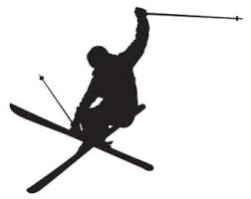](http://www.google.ca/url?sa=i&rct=j&q=&esrc=s&frm=1&source=images&cd=&cad=rja&docid=kGwOtLFzUi18hM&tbnid=dzS-mp7X7Oq6kM:&ved=0CAUQjRw&url=http://www.etsy.com/market/silhouette_decal&ei=CVD4UtCzIsTeqQGi6oGADA&psig=AFQjCNGszX80D6heHDCGxDknkt0PtTNnkg&ust=1392091382338869)

[](http://www.google.ca/url?sa=i&rct=j&q=&esrc=s&frm=1&source=images&cd=&cad=rja&docid=ny12KjoMHhnMEM&tbnid=AZPXunKcfhjbrM:&ved=0CAUQjRw&url=http://plasmaspider.com/viewtopic.php?f=6&t=9116&ei=gVD4UvrXJIacqgHpw4DADA&psig=AFQjCNHwO4A8pLVvk2f7_sgrD6hh7dB3bQ&ust=1392091587938051)

[](http://www.google.ca/url?sa=i&rct=j&q=&esrc=s&frm=1&source=images&cd=&cad=rja&docid=ny12KjoMHhnMEM&tbnid=AZPXunKcfhjbrM:&ved=0CAUQjRw&url=http://plasmaspider.com/viewtopic.php?f=6&t=9116&ei=gVD4UvrXJIacqgHpw4DADA&psig=AFQjCNHwO4A8pLVvk2f7_sgrD6hh7dB3bQ&ust=1392091587938051)

[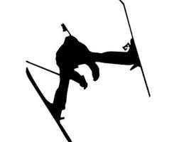](http://www.google.ca/url?sa=i&rct=j&q=&esrc=s&frm=1&source=images&cd=&cad=rja&docid=3VoWWPXv8VPOvM&tbnid=843JCxOjYYZJoM:&ved=0CAUQjRw&url=http://www.etsy.com/market/sport_ski&ei=pVH4UobaOIPlyQGNuIGQBg&psig=AFQjCNHNLUnQMFWWg-h009nGjbRSrDRQKA&ust=1392091911066469)

[](http://www.google.ca/url?sa=i&rct=j&q=&esrc=s&frm=1&source=images&cd=&cad=rja&docid=ny12KjoMHhnMEM&tbnid=AZPXunKcfhjbrM:&ved=0CAUQjRw&url=http://plasmaspider.com/viewtopic.php?f=6&t=9116&ei=gVD4UvrXJIacqgHpw4DADA&psig=AFQjCNHwO4A8pLVvk2f7_sgrD6hh7dB3bQ&ust=1392091587938051)

[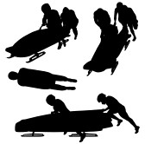](http://www.google.ca/url?sa=i&rct=j&q=&esrc=s&frm=1&source=images&cd=&cad=rja&docid=0aH7nnMbzASUIM&tbnid=VHYwtqlEj6xDKM:&ved=0CAUQjRw&url=http://www.123rf.com/photo_15881954_bobsleigh-silhouette-on-white-background.html&ei=7VH4UvK6BYLcrAGDiYGQBw&psig=AFQjCNHNLUnQMFWWg-h009nGjbRSrDRQKA&ust=1392091911066469)

[](http://www.google.ca/url?sa=i&rct=j&q=&esrc=s&frm=1&source=images&cd=&cad=rja&docid=NuS_i51RD0YaeM&tbnid=k-D8zLLQUzOPzM:&ved=0CAUQjRw&url=http://www.stickthisgraphics.com/Skiing-Snowboard-Decals-Stickers_c99.htm&ei=aFL4UpiFC8OBrgH7gYHoAg&psig=AFQjCNHRo11Q6mEFjbyTzqWFiKPVKt14aw&ust=1392092056770700)

[](http://www.google.ca/url?sa=i&rct=j&q=&esrc=s&frm=1&source=images&cd=&cad=rja&docid=MnhzGTHxNk1H3M&tbnid=mw1bhw8OC47FCM:&ved=0CAUQjRw&url=http://www.clker.com/clipart-snowboarder-silhouette.html&ei=M1L4UvbYE8GUqgGfy4DwCg&psig=AFQjCNHRo11Q6mEFjbyTzqWFiKPVKt14aw&ust=1392092056770700)

[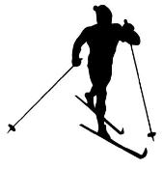](http://www.google.ca/url?sa=i&rct=j&q=&esrc=s&frm=1&source=images&cd=&cad=rja&docid=NuS_i51RD0YaeM&tbnid=WUpvO20tz5yVwM:&ved=0CAUQjRw&url=http://www.stickthisgraphics.com/Skiing-Snowboard-Decals-Stickers_c99.htm&ei=tVL4UsLrKIL4yQHRqYGAAQ&psig=AFQjCNFURNJTIDJqId9wwRFWNlG5uByhLQ&ust=1392092186305754)

[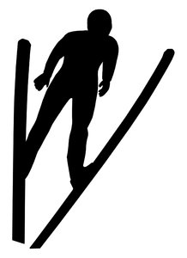](http://www.google.ca/url?sa=i&rct=j&q=&esrc=s&frm=1&source=images&cd=&cad=rja&docid=M41QQSv68e-42M&tbnid=JL1uimqqcVhQxM:&ved=0CAUQjRw&url=http://www.ebay.co.uk/itm/Ski-Jumper-Symbol-Sport-Silhouette-Vinyl-Wall-Art-Sticker-Present-Eagle-Jumping-/321019244140&ei=JlP4UqiZHsearQGlooHIDg&psig=AFQjCNFMcZmFiECG6MKP0Eq9Ft5diBTY3w&ust=1392092295783729)