Get Students Talking…
About their Art and Creative Process

COMMUNICATE: Students will be expected to reflect on and respond to their own and others’ art works.
-Gr. 2 Visual Arts Education; DRAFT document

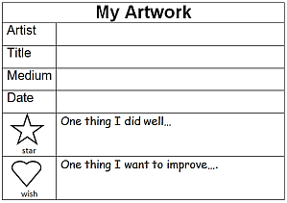
K-2.4.3 choose and present work from their portfolio
- “One Star/One Wish” format for presenting:
Star = “One thing I did well...”
Wish = “One thing I could have or would like to improve...”

- “Art Walk” –invite students to walk around the room to view others’ creations (e.g., mid-process, or when each student has chosen a favourite piece from his/her portfolio to share)

K-2.4.4 use descriptive language to talk about their own work and that of their peers
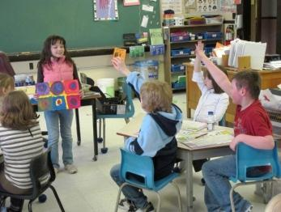
- invite artists to share their work with the class (students label their work ahead of time with artist’s name, title, medium, date), then peers might respond using a ‘Two Comments (e.g., “I like the way you...”) and a Question’ (e.g., “How did you make that colour?”) format.
K-2.4.5 explain the problem-solving (how and why) that occurred during the art-making process
- Discussion topics may include the subject, the colours, the shapes, the placement, effects or techniques. Discussion formats may vary and include pairs, small groups, whole class, teacher conference, etc
More Suggestions:

Smartboard Spinner
- Visit http://elementaryvisualart.weebly.com/quick-classroom-visuals.html

10 ‘Tried & Tested’ Discussion Prompts (from ‘The Art of Education’; www.theartofed.com)
- What materials did you use for this piece? How did you use them?
- Describe your idea behind the artwork. Where did it come from?
- Tell me a story about your artwork.
- How did you make the color choices in your artwork?
- What Elements of Design did you use? Show me where you used them.
- If you could do this piece again, what would you change?
- What is your favorite piece you created, and why?
- What is one goal you have for art class this year?
- What ideas do you have to display this artwork in your home?
- Name 3 artists you learned about this semester. Tell me more about them!

Compiled by H. Stoddart; ASD-S Elementary Visual Arts; Nov. 2013
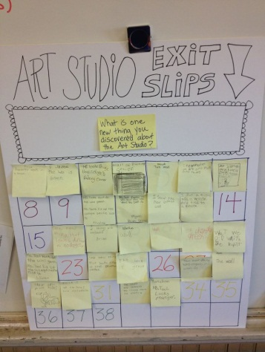
Exit Slips: Samples from ‘The Art of Education’
Retrieved November 2013 from http://www.theartofed.com/2013/03/14/using-exit-slips-in-the-art-room/
- What is one thing you learned in the art today?
- The most important thing I learned today was…
- My favorite thing I learned in art today was…
- I need help with…
- What are you confused about regarding what you learned today?
- What could you have done differently to help you learn better today?
- How can what you’re learning in art be applied to your daily life?
- I wish…
- The thing that surprised me today was…
Image retrieved November 2013 from
http://www.pinterest.com/pin/168814686005258148/
Sticky Notes : Open-ended… “What stuck today?”
- Specific topic/question
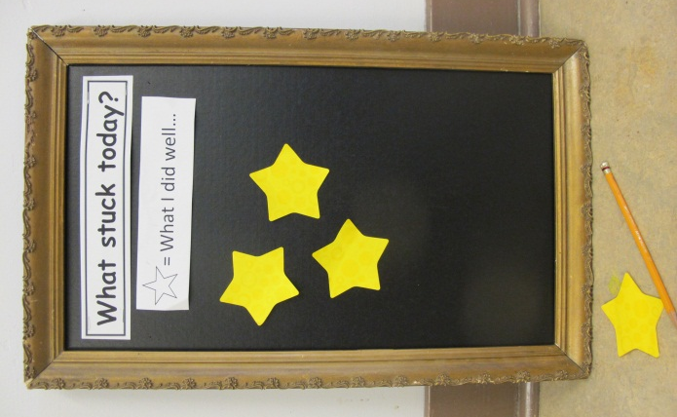
- What I did well
- What I wish to improve

‘Art Deck’… On-the-Fly Binder of Art Questions
Download at http://www.theartofed.com/2011/05/09/question-deck-download/
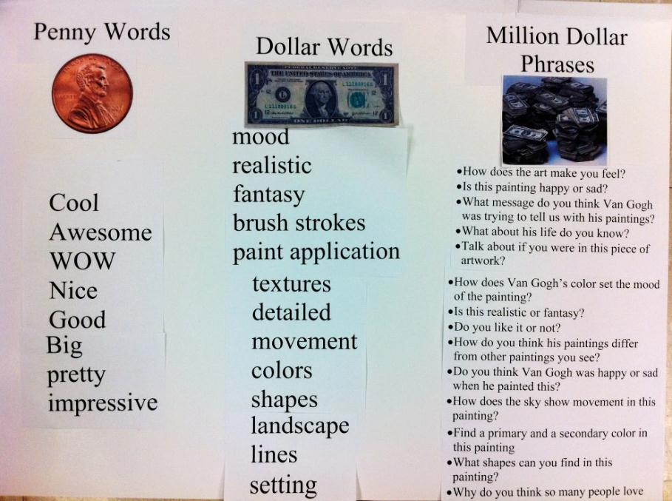
Poster Idea from ‘The Art of Education’

Image retrieved Nov. 2013 from http://www.theartofed.com/2010/12/05/how-to-talk-to-kids-about-art/

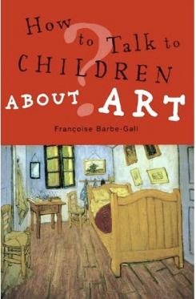
TEXT: “How to Talk to Children About Art”
(‘Helpful Tips’ summarized by Jessica Balsley, Art of Education):
- Use the Elements and Principles of Design as a starting point (what shapes, lines, colors, textures, etc do you see?)
- Make sure your questions are age appropriate and adjust your questioning appropriately.
- Connect it to the student’s life and interests
- Ask students about emotions they feel when looking at the art and how it makes them feel
- Link to Literature: What story does this painting tell?

